Login & Team Page Restyling
Design Review & UX Handoff — Sprint 1
F1 Ticketing Platform Redesign · Bootstrap restyle · Reviewed against the Sprint 1 requirements draft
Field | Detail
Deliverables under review | Team page restyle; Login screen restyle (Bootstrap)
Requirements reference | “Requirements: Team Page & Login Restyling (Bootstrap)” — Sprint 1 draft
Reviewer | Matthew Kwong
Review date | 16/8/26
Overall status | Approved with conditions

2. Team page — field coverage
Field | Req / Opt | Requirement | Stability | Represented? | Notes / screen ref
Member name | Required | Always displayed; used as image alt text. | STABLE | Yes | [1]
Role / title | Required | Short text; wraps or truncates consistently. | MAY CHANGE | Yes | Included underneath member’s name inside [1]
Photo / avatar | Optional | Fixed aspect ratio; placeholder if missing. | MAY CHANGE | Yes | Included above member’s name inside [1]
Email / contact | Optional | If valid, render as a mail to link. | MAY CHANGE | No | Not necessary required
Department / sub-team | Optional | Used for grouping or a badge. | MAY CHANGE | No | Not necessary required
Short bio | Optional | Truncate long text; “read more” optional. | MAY CHANGE | Yes | Included within the member card with a short description describing the person’s role [1]
Social / profile links | Optional | Icons; hidden when none provided. | MAY CHANGE | No | Not necessary required

3. Team page — display & validation rules
Rule | Stability | Met? | Notes
Required fields always render; optional fields hide cleanly when empty — no blank gaps. | STABLE | Yes | Name and role render on every card; the optional fields (email/contact, department, social links) are omitted rather than shown blank, so each card stays visually complete with no empty gaps [1].
Photos use a fixed aspect ratio; placeholder on missing / broken source; blank avatar picture | STABLE | Yes | When the photo of the user isn’t present it displays the blank avatar picture to compensate the empty field
Long names, roles and bios wrap or truncate consistently across cards. | STABLE | Yes | When the screen width is reduced, or the description exceeds the member card's maximum character length, the text wraps so the full content stays visible and readable.
Responsive: multi-column grid on desktop collapsing to a single column on mobile. | STABLE | Yes | It successfully reduces the number of member card that can exist within that column when the width of screen reaches a certain width to compensate for compressing the member card.
Email, if present, is validated before rendering as a link. | MAY CHANGE | No | Not necessary
Ordering of members (alphabetical, by role, manual) — to be confirmed. | MAY CHANGE | No | Not necessary

4. Login — styling-only conformance
4.1 In scope — restyled elements (should be present)
Element | Restyled? | Notes / screen ref
Submit button | Yes | The colour of the button has been change from a red colour[2] to a green button [3].
Logo, spacing, colours, typography | Yes | Instead of the original card design with sign in and create account with a base colour of red[2]. We have shifted to a green colour, additionally sign in and create account takes up half of the screen with a much larger text[4].

4.2 Out of scope — the styling-only boundary (should be ABSENT)
Prohibited change | Present? | Notes
Change to authentication logic, sessions, redirects or password rules | No | The Authentication logic did not change instead implemented the existing logic.
Adding, removing or reordering fields | No | Even though the colour has changed the fields and the ordering of the field did not change
Any change to validation behaviour | No | Same with the Authentication logic as we have implemented the existing logic during the design phase.

5. Edge-case coverage
Each defined edge case must have a visible state in the mockup — an actual screen or component, not an assumption.
5.1 Team page
Edge case | Visible treatment? | Screen / state ref | Notes
Broken or missing member photo (falls back to placeholder) | Yes | [1] | None of the five members has an uploaded photo, so every card renders the circular initial-based avatar placeholder (KD, BL, JR, TD) at a fixed size — the fallback is exercised across the whole roster.
Very long name, role or bio (wrap / truncate without breaking layout) | Partial | [1] | Bios wrap to multiple lines inside the card (see the two-line bio on the Matthew (Kar Wei) Kwong card) without breaking the grid. However, no genuinely long name or role appears in the sample data, so truncation of an over-length name/role is not yet evidenced.
Zero members — defined empty state | No | — | No empty state is shown; the mockup only depicts a populated roster of five members. A “no team members yet” state still needs to be designed. Flagged in Section 6.
Large number of members — scroll vs pagination (threshold TBD) | No | — | Only five members are shown and they fit on one screen, so neither a scroll nor a pagination pattern is demonstrated. The paging threshold remains TBD (Section 7). Flagged in Section 6.
Missing optional fields — card still looks complete | Yes | [1] | Email/contact, department and social links are all absent, yet each card still reads as complete (avatar, name, role, bio) — confirming optional fields collapse cleanly without leaving gaps.
Non-Latin characters, accents or special symbols in names | Partial | [1] | All sample names are Latin, so accented/non-Latin rendering is untested. A special-symbol case is present and reveals a defect: “Matthew (Kar Wei) Kwong” produces the avatar initials “M(” instead of “MK” — the initials logic treats the bracket as a word. Flagged in Section 6.
Mismatched photo dimensions or orientation | No | — | No real photos are loaded (all cards use the circular initial placeholder), so behaviour with off-ratio or portrait/landscape source images cannot be assessed from this mockup.

5.2 Login
Edge case | Visible treatment? | Screen / state ref | Notes
Browser autofill overriding custom field styling | No | — | Not demonstrable from a static mockup; no autofilled state is shown. Needs to be verified against the built login form.
Long error messages overflowing their container | No | — | No error or validation state is shown in the mockup, so error-message layout and overflow handling are not evidenced.
Small / narrow screens | No | [4] | Only the wide two-column desktop layout is shown [4]; there is no mobile/narrow breakpoint. How the split hero/form collapses on small viewports is not yet designed. Flagged in Section 6.
Button loading and disabled states during submit | No | — | Only the default green “Sign in” button [3] is shown — no loading spinner or disabled state during submission is depicted.
Keyboard focus visibility for accessibility | No | — | Focus rings and keyboard states are not shown in the static mockup and cannot be verified. Depends on the accessibility target still to be confirmed (Section 7).
Sufficient colour contrast on text, buttons and error states | Partial | [4] | The green “Sign in” button with dark text and the white “Sign in” heading read as high-contrast. Several secondary greys (field labels, helper copy, placeholder text on the dark panel) look borderline and should be measured against the chosen WCAG target. Error-state contrast is untested (no error shown).

6. Gaps flagged to UX
# | Screen | Req ref | Gap / issue | Severity | Raised with (UX) | Status
1 | Team page [1] | 5.1 — special symbols in names | Avatar initials break on punctuation: “Matthew (Kar Wei) Kwong” renders as “M(” instead of “MK”. Member name is a required, always-displayed field. | Blocking | Yes | Open
2 | Team page [1] | 5.1 — zero members | No empty state is designed for a team with zero members; only a populated roster exists. | Confirm | Yes | Open
3 | Team page [1] | 5.1 — large list | No scroll or pagination behaviour for a large roster, and the paging threshold is undefined. | Confirm | Yes | Open
4 | Login [4] | 5.2 — narrow screens | Only the desktop two-column layout is shown; no mobile/narrow breakpoint for the split login. Responsive behaviour is a stable expectation. | Blocking | Yes | Open
5 | Login [4] | 5.2 — a11y & states | No focus-visibility, button loading/disabled or error states; some secondary text contrast is borderline against an unconfirmed WCAG target. | Confirm | Yes | Open

7. Dependencies blocking final approval
Open item | Needed for | Blocks sign-off of | Status
Confirm Team page purpose (roster vs manage-team) | Whole design direction | Sections 2–3 | Stable
Final field list + required vs optional | Card layout & rules | Section 2 | Stable
Source of team data (static list vs database / API) | Empty & large-list states | Section 5.1 | Stable
Brand assets — colours, fonts, logo | Visual design | Section 4.1 | Stable
Accessibility target (e.g. WCAG 2.1 AA) | Contrast & focus rules | Section 5 (a11y) | Stable
Real copy and member data | Content & truncation limits | Sections 2, 5 | Stable
Pagination threshold (members before paging) | Large-list edge case | Section 5.1 | Stable
Current login markup | Enforcing styling-only | Section 4.2 | Stable
Localization / RTL needs | Text handling | Section 5 (non-Latin) | Stable

8. Review decision & sign-off
Field | Detail
Decision | ☐ Approved ☒ Approved with conditions ☐ Blocked — pending
Conditions / next steps | Close the five gaps in Section 6 before final sign-off: (1) fix the avatar-initials bug for names containing punctuation/special symbols; (2) design a zero-members empty state; (3) define and implement the large-list scroll/pagination threshold; (4) add a mobile/narrow-screen layout for the login; and (5) confirm the accessibility target, then add focus, loading/disabled and error states. Sign-off also remains blocked on the open dependencies in Section 7 (Team-page purpose, final field list, data source, brand assets, a11y target, real copy, pagination threshold, current login markup, and localization/RTL).
Mockup version signed off | Sprint 1 low-fidelity mockup — v1
Reviewer | Matthew Kwong — Business Analyst
Date | 16/8/26

[1]
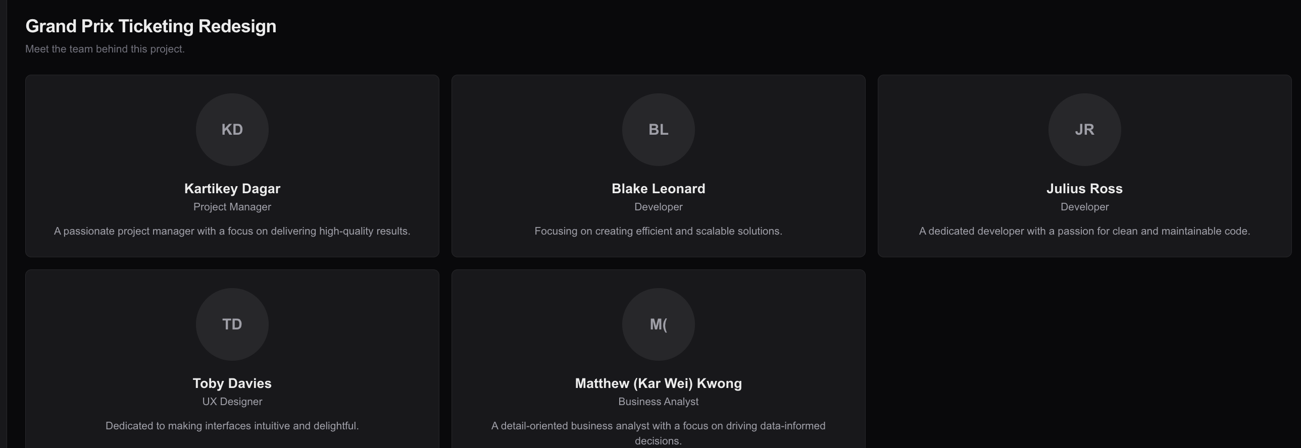

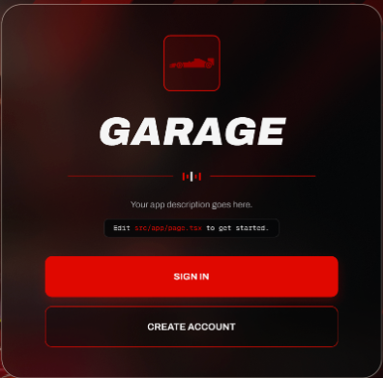
[2]

[3]


[4]
